Walkthrough - Template

Contents

Host Discovery 2

Nmap 2

Nikto 2

Dirb 2

Viewing Website 2

Exploitation 2

Escalation 2

# Host Discovery



# Nmap



# Nikto



# SMBClient

Connect to smb server.

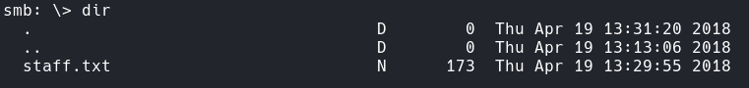



# Viewing Website

The /development/ directory shows 2 text files for download.

# A screen shot of a computer Description automatically generatedSearchsploit

Since one of the files talked about apache struts then it could be the top exploit.

This doesn’t work.

# Enum4Linux

I identified some users.



# Hydra

Since I know that “Jan” has an easy password, I will use this time to crack it.



# Escalation

Now that I am in, I can begin finding exploit points. In Kays home directory that is a hidden .ssh directory containing all of the keys. I can actually read the contents. I copied it over to my Kali machine and started john to begin cracking.

# SSH2John



# John

# SSH – Kay



In the home directory of Kay there is also a “pass.bak” file.

heresareallystrongpasswordthatfollowsthepasswordpolicy$$

Now with the password I can see what I can do.

# Sudo Privileges

I can run all commands in sudo.

# Root Exploit

# A screenshot of a computer Description automatically generatedFlag